Salesforce App builder mini case study

**Aadyarth Academy Pune**

Dipti Anjarlekar

This Document will help you to practice how to configure user interface as per business requirement

Case Study 1

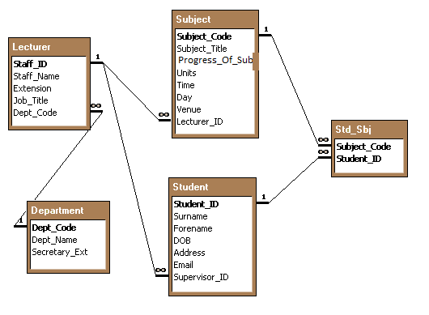

**Object Related to (Relationship)**

Lecturer Student (Detailed object of Lecturer)

Department (Detailed object of Lecturer)

Subject (Detailed object of Lecturer)

Student Std_Sub (Detailed object of Student)

Subject Std_Sub (Detailed object of Subject)

1. Create **‘University’** as an application having different Custom Objects and Custom Fields as mentioned in the ER diagram
2. **Student** Object should follow below formatting:
   1. **Age** should be calculated automatically
   2. **Address** should have below values:
      1. Pune
      2. Mumbai
      3. Kolkata
      4. Chennai
      5. Bangalore
      6. Hyderabad
   3. Address should get filter on **Country** field
3. Subject Object should follow below formatting:
   1. Progress of Subject can have below values:
      1. On going
      2. Cancelled
      3. Completed
4. Validation:
   1. Student’s DOB cannot be more than today’s date and student should be more than 15 years to enroll for the University
5. Workflow:
   1. If lecturer cancels her lecture, she would like to intimate her students through mails
6. Create appropriate related list wherever required.

Case study 2

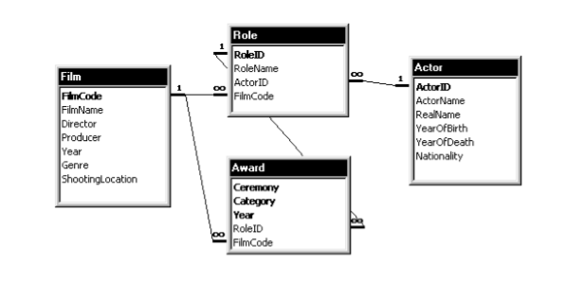

**Object Related to (Relationship)**

Film Award (Detailed object of Film)

Role (Detailed object of Film)

Role Actor (Detailed object of Role)

Award (Detailed object of Role)

Actor Role (Detailed object of Actor)

1. Create **‘Film’** as an application having different Custom Objects and Custom Fields as mentioned in the ER diagram
2. **Actor** Object should follow below formatting:
   1. **Age** should be calculated automatically
3. **Film** Objectshould follow below formatting:
   1. **Total_Number_of_Awards** received
4. Validation:
   1. For a film, **Director** and **Producer** fields cannot be empty.
   2. **Year** field in award should not be less than year field in Film object
5. Workflow:
   1. On receiving even a single award, actor should get 5 rating .
6. Create appropriate related list wherever required.

Case Study 3

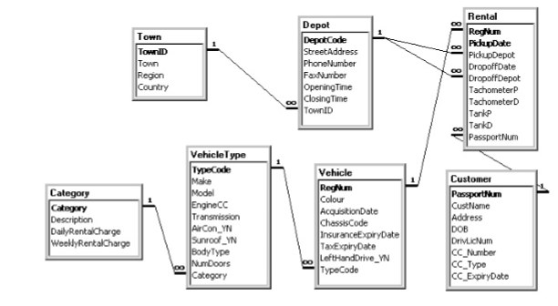

Notes: i) In the Rental table, the fields TachometerP and TachometerD record the tachometer readings (“trip counter”) of the vehicle in kilometers at date of pick-up and date of drop-off respectively.

ii) In the Rental table, the fields TankP and TankD record the petrol tank levels of the vehicle in litres at date of pick-up and date of drop-off respectively.

1. Create **‘Vehicle Rentle System’** as an application having different Custom Objects and Custom Fields as mentioned in the ER diagram
2. **VehicleType** Object should follow below formatting:
   1. The **BodyType** of a vehicle is “Hatchback”, “Sedan”, “Estate”, or Null.
   2. **AirCon_YN, Sunroof_YN and LeftHandDrive_YN** are all boolean Yes/No fields with values “Y” or “N
   3. The **Transmission** of a vehicle is either “Automatic” or “Manual”.
   4. The basic charge periods are per day and per week. If, for example, the daily rental charge for a vehicle were 35 Euros and the weekly rental charge were 200 Euros, a 4-day-**rental** would cost 140 Euros (4 * 35) whereas a 9-day-**rental** would cost 270 Euros (200 + 2 * 35).
3. Validation:
   1. **OpeningTime** of Depot should be less than **ClosingTime**
4. Workflow:
   1. The company would like to offering a loyalty bonus letter to all customers who clocked up 3000km.